C:\Documents and Settings\suzy\Local Settings\Temporary Internet Files\Content.IE5\3JXW24R5\MC900383922[1].wmfSunday 5th February, 2017

Name:

Class:

Finish Date: Saturday 11th February, 2017

Completed Bible Study = 15 points

Email Homework by the due date = 5 points

**Year 5 Bible Study Matthew Chapter 1 & 2**

**For the questions below Highlight, underline or change the font colour to choose the correct answer.**

□ Monday: Read **Matthew Chapter 1: 1-17** and answer the questions:

### The Geneology of Christ

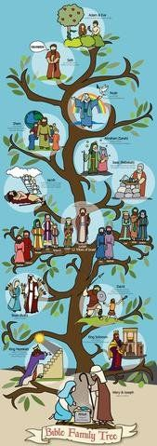*1The book of the genealogy of Jesus Christ, the Son of David, the Son of Abraham: Abraham begot Isaac, Isaac begot Jacob, and Jacob begot Judah and his brothers. 3Judah begot Perez and Zerah by Tamar, Perez begot Hezron, and Hezron begot Ram. 4Ram begot Amminadab, Amminadab begot Nahshon, and Nahshon begot Salmon. 5Salmon begot Boaz by Rahab, Boaz begot Obed by Ruth, Obed begot Jesse, 6and Jesse begot David the king.*

*David the king begot Solomon by her who had been the wife[a] of Uriah. 7Solomon begot Rehoboam, Rehoboam begot Abijah, and Abijah begot Asa.[b] 8Asa begot Jehoshaphat, Jehoshaphat begot Joram, and Joram begot Uzziah. 9Uzziah begot Jotham, Jotham begot Ahaz, and Ahaz begot Hezekiah. 10Hezekiah begot Manasseh, Manasseh begot Amon,[c] and Amon begot Josiah. 11 Josiah begot Jeconiah and his brothers about the time they were carried away to Babylon.*

*12 And after they were brought to Babylon, Jeconiah begot Shealtiel, and Shealtiel begot Zerubbabel. 13Zerubbabel begot Abiud, Abiud begot Eliakim, and Eliakim begot Azor. 14Azor begot Zadok, Zadok begot Achim, and Achim begot Eliud. 15Eliud begot Eleazar, Eleazar begot Matthan, and Matthan begot Jacob. 16And Jacob begot Joseph the husband of Mary, of whom was born Jesus who is called Christ.*

*17So all the generations from Abraham to David are fourteen generations, from David until the captivity in Babylon are fourteen generations, and from the captivity in Babylon until the Christ are fourteen generations.*

**Question 1**

Chapter 1 begins with telling us about the ‘genealogy of Jesus Christ’. Genealogy explains who the great (great) grandfathers were, where Christ came from. Use verses 1 to 17 to learn about some of the important people who were in the genealogy of Christ. Can you guess who these 3 important people are:

1. A_ _ _ _ _ _
2. D_ _ _ _
3. J_ _ _ _ _

□ Tuesday: Read **Matthew Chapter 1: 18-24** and answer the questions:

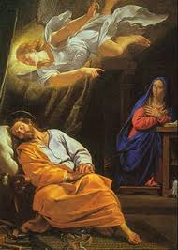**Christ born of Mary**

*18Now the birth of Jesus Christ was as follows: After His mother Mary was betrothed to Joseph, before they came together, she was found with child of the Holy Spirit. 19Then Joseph her husband, being a just man, and not wanting to make her a public example, was minded to put her away secretly. 20But while he thought about these things, behold, an angel of the Lord appeared to him in a dream, saying, “Joseph, son of David, do not be afraid to take to you Mary your wife, for that which is conceived in her is of the Holy Spirit. 21And she will bring forth a Son, and you shall call His name Jesus, for He will save His people from their sins.”*

*22So all this was done that it might be fulfilled which was spoken by the Lord through the prophet, saying: 23“Behold, the virgin shall be with child, and bear a Son, and they shall call His name Immanuel,” which is translated, “God with us.”*

*24Then Joseph, being aroused from sleep, did as the angel of the Lord commanded him and took to him his wife, 25and did not know her till she had brought forth her firstborn Son.[d] And he called His name JESUS.*

**Question 2**

True or False (Highlight , **bold**, or underline the correct answer).

1. Mary was pregnant before marrying Joseph TRUE/ FALSE
2. An angel appeared to Joseph, explaining that the child is of the Holy Spririt TRUE/ FALSE
3. Immanuel means “God saves” TRUE/ FALSE

**Question 3**

What was Mary’s baby named?

□ Wednesday: Read **Matthew Chapter 2: 1-27** and answer the questions:

**Wise Men from the East**

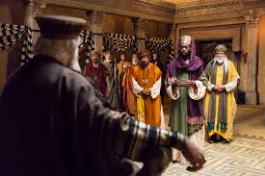*2Now after Jesus was born in Bethlehem of Judea in the days of Herod the king, behold, wise men from the East came to Jerusalem, 2 saying, “Where is He who has been born King of the Jews? For we have seen His star in the East and have come to worship Him.” 3When Herod the king heard this, he was troubled, and all Jerusalem with him. 4And when he had gathered all the chief priests and scribes of the people together, he inquired of them where the Christ was to be born. 5So they said to him, “In Bethlehem of Judea, for thus it is written by the prophet:*

*6‘But you, Bethlehem, in the land of Judah,*

*Are not the least among the rulers of Judah;*

*For out of you shall come a Ruler*

*Who will shepherd My people Israel.’”[a]*

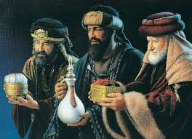*7Then Herod, when he had secretly called the wise men, determined from them what time the star appeared. 8 And he sent them to Bethlehem and said, “Go and search carefully for the young Child, and when you have found Him, bring back word to me, that I may come and worship Him also.”*

*9 When they heard the king, they departed; and behold, the star which they had seen in the East went before them, till it came and stood over where the young Child was. 10When they saw the star, they rejoiced with exceedingly great joy. 11And when they had come into the house, they saw the young Child with Mary His mother, and fell down and worshiped Him. And when they had opened their treasures, they presented gifts to Him: gold, frankincense, and myrrh.*

*12Then, being divinely warned in a dream that they should not return to Herod, they departed for their own country another way.*

**Question 4**

Who was the king at the time of Jesus’ birth? (Highlight , **bold**, or underline the correct answer).

1. Caesar
2. Herod
3. Agrippa

**Question 5**

What does the word ‘prophet’ mean?

**Question 6**

How are the kings warned not to return to Herod?

□ Thursday: Read **Matthew Chapter 2: 13-18** and answer the questions:

**The Flight into Egypt**

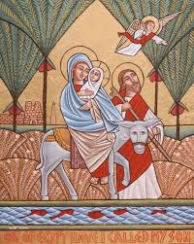*13Now when they had departed, behold, an angel of the Lord appeared to Joseph in a dream, saying, “Arise, take the young Child and His mother, flee to Egypt, and stay there until I bring you word; for Herod will seek the young Child to destroy Him.”*

*14When he arose, he took the young Child and His mother by night and departed for Egypt, 15and was there until the death of Herod, that it might be fulfilled which was spoken by the Lord through the prophet, saying, “Out of Egypt I called My Son.”[b]*

**Massacre of the Innocents**

*16Then Herod, when he saw that he was deceived by the wise men, was exceedingly angry; and he sent forth and put to death all the male children who were in Bethlehem and in all its districts, from two years old and under, according to the time which he had determined from the wise men. 17Then was fulfilled what was spoken by Jeremiah the prophet, saying: 18“A voice was heard in Ramah,Lamentation, weeping, and great mourning, Rachel weeping for her children, Refusing to be comforted, Because they are no more.”[c]*

**Question 7**

a) Why does the angel warn Joseph to flee to Egypt in his dream?

b) What does Herod do, that completes the prophecies of Jeremiah?

□ Friday: Read **Matthew Chapter 2: 19-36** and answer the questions:

### The Home in Nazareth

*19 Now when Herod was dead, behold, an angel of the Lord appeared in a dream to Joseph in Egypt, 20saying, “Arise, take the young Child and His mother, and go to the land of Israel, for those who sought the young Child’s life are dead.” 21Then he arose, took the young Child and His mother, and came into the land of Israel.*

*22But when he heard that Archelaus was reigning over Judea instead of his father Herod, he was afraid to go there. And being warned by God in a dream, he turned aside into the region of Galilee. 23And he came and dwelt in a city called Nazareth, that it might be fulfilled which was spoken by the prophets, “He shall be called a Nazarene.”*

**Question 8**

a) Joseph is told in a dream to return to Israel. Why does the angel say it is safe to return?

b) Complete the verse: “He shall be called a .”

□ Saturday: **MEMORY VERSE**:

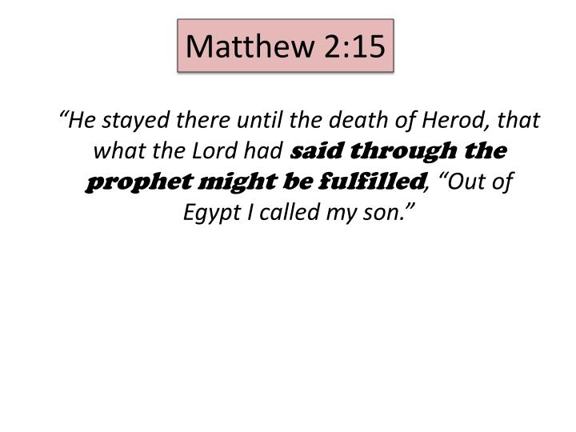

**What to do when you finish your Bible Study.**

Send it by email to your class email address or print and hand it to your servants next Sunday.

* Year 5B1 St Thomas[stthomas5b@gmail.com](mailto:stthomas5b@gmail.com) Class Servant- Uncle Andrew (0416744100)
* Year 5B2 St Philip[saintphilip5g@gmail.com](mailto:saintphilip5g@gmail.com) Class Servant- Uncle Mark (0413495921)
* Year 5G St Matthew [stmatthew5g@gmail.com](mailto:stmatthew5g@gmail.com) Class Servant – Aunty Dina (0404604507)